ACTION & DISCUSSION ITEMS

- Domain Coverage Matrix: Map the platform’s capabilities and services against the customer’s seven domains, including existing, planned, in-progress, unavailable, and AI-enabled functionality, and include readiness percentages plus gaps and estimated development timeframes.
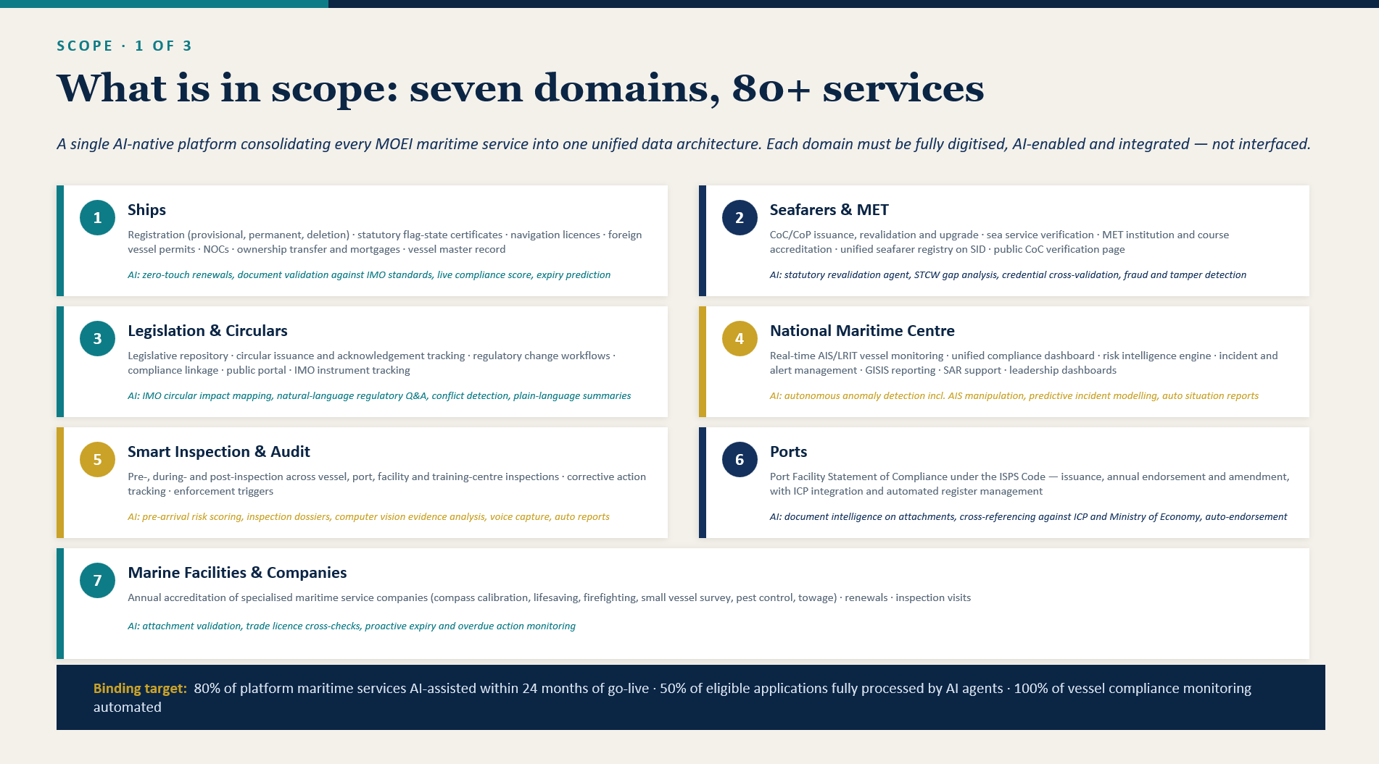
- Competitor Analysis: Compare the platform with the identified competitor platform (especially Kongsberg) across the seven customer domains and document differentiators, capability gaps, and competitive advantages.
Maritime Platform | Primary Focus Area
DNV Veracity | Maritime Data Exchange, Compliance, ESG & Regulatory Intelligence
ABS Wavesight | Maritime Compliance, Fleet Governance, Inspections & Asset Intelligence
Windward Maritime AI | Maritime Intelligence, Risk Analytics, Vessel Monitoring & AI Insights
Maqta Technologies (AD Ports) | UAE Smart Ports, Trade Facilitation, Maritime Digital Platforms
KALE Logistics | Port Community Systems & Trade Ecosystem Digitization
Kongsberg (Kognifai / PMIS) | Maritime Data Platform, Port Operations, IoT & Digital Monitoring
Wärtsilä Voyage | Voyage Optimization & Fleet Operations
Kaleris – Navis N4 | Terminal Operating System & Container Operations
MariHub | Maritime Procurement & Supplier Collaboration

- Customer References & Case Studies: Provide Customer References & Prepare case studies, including the Mundra/ Adani port and Siemens use cases, for inclusion in the proposal.
- Architecture Readiness: Assess the current architecture’s readiness, flexibility, and extensibility for modernization toward microservices and a low-code/no-code platform and provide a realistic roadmap and readiness estimate.
- AI Capability Mapping: Map the customer’s required AI use cases to existing platform agents and identify additional AI agents or capabilities that must be developed.
- UAE Domain Compliance: Validate the platform against UAE maritime regulations, safety standards, inspection requirements, vessel and port rules, and other applicable local compliance needs, using appropriate maritime subject-matter expertise.
- Proposal Requirements: Complete the domain, capability, and effort mapping

